EmStat Pico can detect the lead, mercury, magnesium, manganese of purification device
Yes, we can detect the lead , mercury, magnesium, and manganese by using the EmStat Pico module. It is a potentiostat and not the sensor; you will need to pair it with specific electrochemical sensors for each metal. It will read the electrochemical data from the sensors, allowing you to detect these elements in a solution. This system is well-suited for developing environmental monitoring projects, especially for detecting heavy metals in water, and is designed to be user-friendly for those without extensive electrochemistry knowledge.
How it works?
Potentiostat:
The EmStat Pico acts as the potentiostat, which is the device that controls the voltage and current for the electrochemical sensor.
Measurement:
The sensor interacts with the sample, and the EmStat Pico reads the resulting electrical response, which corresponds to the concentration of the target metal.
Detection of specific metals
Lead and mercury:
These are common targets for electrochemical sensors, especially in environmental water analysis.
Manganese and magnesium:
While less frequently discussed in the context of environmental heavy metal monitoring compared to lead or mercury, electrochemical sensors can be developed to detect these ions as well, depending on the specific application and sensor design.
Can We Detect Lead, Mercury, Manganese, and Magnesium?
Yes, the EmStat Pico can detect these metals, but with important considerations:
Excellent Detection Capability:
- Lead (Pb) - Highly detectable
- Mercury (Hg) - Highly detectable
- Manganese (Mn) - Detectable
Lead and mercury are among the most commonly targeted heavy metals for electrochemical sensor detection, along with arsenic, cadmium, and chromium ACS PublicationsPubMed Central.
Challenging:
- Magnesium (Mg) - More difficult to detect electrochemically compared to heavy metals
Key Technical Details
Detection Techniques
The EmStat Pico supports electrochemical methods ideal for heavy metal detection:
- Anodic Stripping Voltammetry (ASV) - Primary method for heavy metals
- Square Wave Voltammetry (SWV) - High sensitivity detection
- Differential Pulse Voltammetry (DPV) - Enhanced signal-to-noise ratio
- Cyclic Voltammetry (CV) - Characterization and analysis
System Components Needed
1. EmStat Pico Module - The potentiostat (measurement instrument)
2. Electrochemical Sensors/Electrodes:
- Working Electrode - Modified electrodes (carbon, gold, bismuth film, etc.)
- Reference Electrode - Ag/AgCl or similar
- Counter Electrode - Platinum or carbon
3. Electrode Modifications for Enhanced Performance:
Modified electrodes using conducting polymers, DNA, enzymes, or nanomaterials can improve detection of heavy metals through stripping voltammetry techniques Modified Electrodes Used for Electrochemical Detection of Metal Ions in Environmental Analysis - PMC
Detection Process
- Pre-concentration Step: Metal ions accumulate on the electrode surface
- Stripping Step: Voltage sweep causes oxidation/reduction, generating current signal
- Signal Analysis: Peak current correlates with metal concentration
Advantages for Your Project
Miniaturized - Perfect for portable/field applications ✅ Multi-metal detection - Can detect multiple metals simultaneously ✅ Cost-effective - More economical than laboratory equipment ✅ Real-time measurement - Rapid on-site analysis Low power consumption - Battery-operated capability ✅ User-friendly - Uses Method SCRIPT programming language
Typical Detection Ranges
For heavy metals like Pb and Hg:
- Detection limits: Parts per billion (ppb) to parts per million (ppm)
- Linear range: Depends on electrode modification and optimization
Implementation Considerations
For Lead & Mercury:
- Well-established protocols available
- Screen-printed electrodes or bismuth-modified electrodes work well
- Good sensitivity and selectivity
For Manganese:
- Requires optimized electrode materials
- May need specific pH conditions
- Less commonly done but feasible
For Magnesium:
- More challenging due to its electrochemical properties
- May require specialized ion-selective electrodes
- Alternative detection methods might be more suitable
Recommended Development Path
- Start with EmStat Pico Development Kit - Includes module, software, and cables
- Select appropriate electrode materials - Commercial screen-printed electrodes or custom-modified electrodes
- Optimize detection parameters - pH, deposition time, voltage range
- Calibration - Use standard solutions of known concentrations
- Validation - Test with real samples
Software & Integration
- MethodSCRIPT™ - High-level scripting for electrochemical methods
- PSTrace - Data acquisition and analysis software
- Compatible with microcontrollers for embedded applications
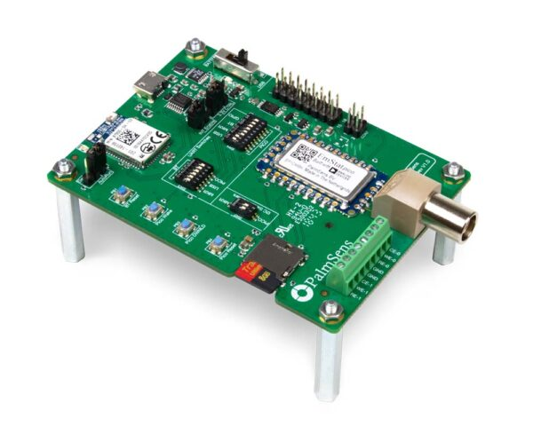
Figure 1:EmStat Pico module

